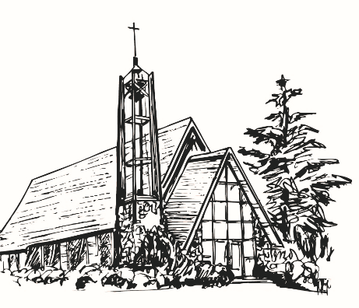
CROSS CURRENTS
October, 2026
Alpine Community Church (UCC), Alpine CA
Vol. 37 No. 010



Women’s Guild News

We began our September by getting organized for our fall meetings. Thank you for those who signed up to be future hostesses. Unfortunately our program from Father Joe’s Villages had an emergency arise and had to cancel. It was a wonderful social gathering catching up on what everyone did over the summer. We exchanged ideas for future meetings and activities.
Our September Bake Sale was once again a success. Thank you to all who took the time to turn on their ovens in the heat wave. We made $447.00. This will start our saving for future mission projects.
Our October meeting program will be presented by Alpine View Lodge. We are in hops that their newest resident, our own Helen Harvey, will be able to join us.
While we are having no Rummage Sale this year, we are planning to have a Christmas Boutique. We have lots of storage so you can bring your gently used items any time starting now.
Happy Fall!
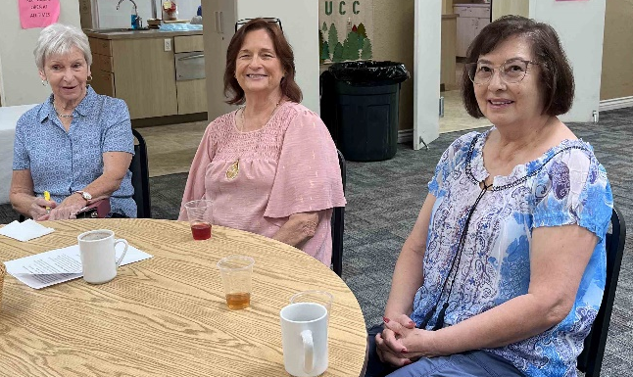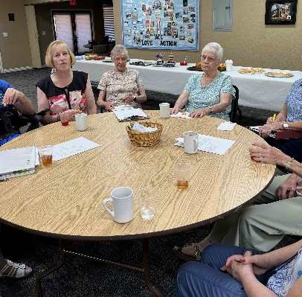
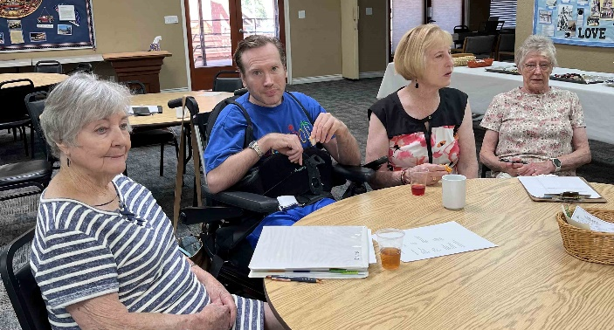

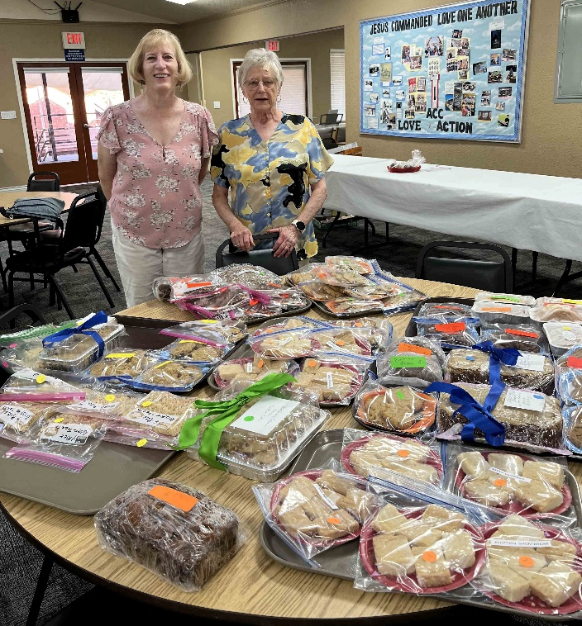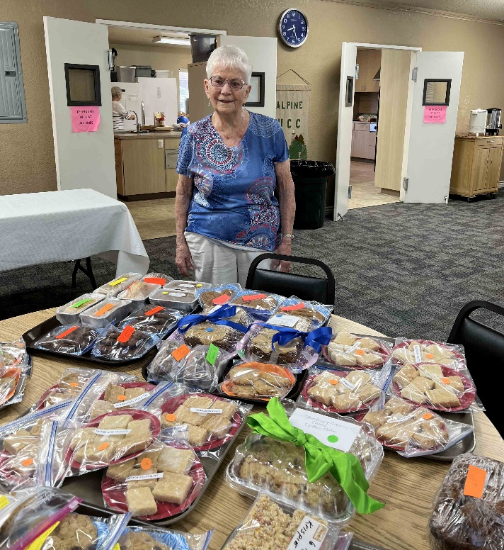

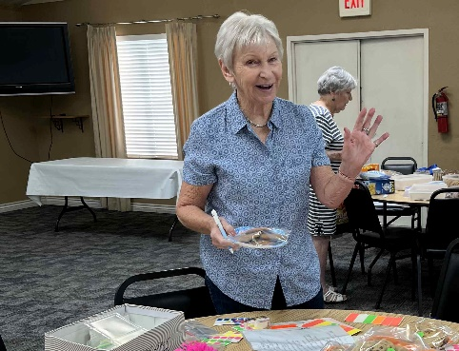

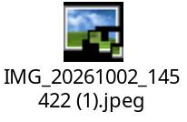
Message from the Interim Designated Term Pastor

und

s



As the calendar officially finds us in the fall season, I cannot help but feel a bit nostalgic for the days of my youth. Growing up in the Midwest, nothing felt quite like the changing and falling of the leaves, blanketing the ground in a crisp sea of oranges, reds, and yellows. We marked those days with trips to the orchards for apple picking, hayrides, cider, and freshly-made donuts. The chilly air sat side by side with the warmth of our cardigans and flannels. The shortening days gave a sense of urgency to the precious daylight hours. Such a wonder to watch the natural world moving through its transformations. It is a reminder that the passage of time and the winds of change can be beautiful things.

Fall is nature’s way of slowing down its processes, of resting and resetting in anticipation of the winter’s arrival and the eventual return of spring. Yet, we cannot rush the seasons any more than we can add a second to our lives. We can only live through them, embracing their pace and adjusting our rhythm to theirs. I embrace the fall season as a sign to release worry, stress, and anxiety the way trees release their leaves. When we recognize that all of life is seasonal, transitional, impermanent, we can accept the joy and beauty of being in the now. This moment, right now, is all we ever truly have. And even that moment slips between our fingertips. We do not control this; our task is to accept it and to live beautifully in the present, neither caught in the past nor fretful about the future.

This is hard work. I wonder if Jesus anticipated this in his words from Matthew 6:27. He poses this question: who among you by worrying can add a single hour to your lifetime? It is a question with an obvious answer – none of us. Yet, this doesn’t keep us from worrying, from doing everything we can to staunch the continual flow of life or striving to make sure things stay just the same.

I will be the first to admit that I am often guilty of moving too quickly and thinking too far ahead. There is a part of me that wants to be prepared for everything that could go wrong or thinking about what I would have done differently. I know all too well the need for grace as I learn to let this day, this minute, this moment, be enough. Just as nature paints its annual portrait of change and transition, let us also be artists, decorating our days with joyful presence and deep contentment.

Message from the Moderator....

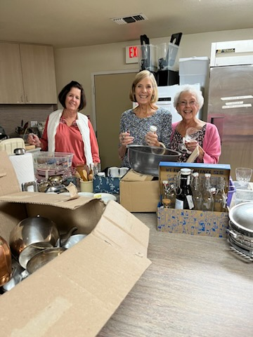

You might think that a smaller church would have an easier time getting things done. Communication should be easier, decisions can be made more quickly, and everyone knows everyone else. But as our church becomes smaller, we are finding that even those things are becoming more difficult.
We have lost choir members and are now down to five. We have lost one Trustee and are about to lose another, leaving us with only three. The Deacons once had a strong team of ten; now there are five. Cabinet used to include a secretary, but the Moderator now assumes that responsibility. The Board of Education once had four members and is now down to two. And we used to have a change in Moderator every couple of years, but I don’t see anyone stepping forward to replace me in 2027. We once had a full-time pastor, and now we have a part-time pastor. And, once again, we need someone to write our newsletter.
Times are changing.
The soul of our church remains intact, even though our numbers do not. We still come together each week to worship God, sing His praises, and share in fellowship. The church remains a family.
And we continue to make a difference in our community. Through the Deacons’ Fund and the Guild’s giving mission, we support a variety of community causes. Each month, we make peanut butter and jelly sandwiches and take them to the Salvation Army. People from our community regularly stop by the church to get food from our Blessing Box. In many ways, we may be a small church, but we continue to have an impact.
So, where do we go from here? How do we grow, or perhaps more importantly, how do we continue?
I don’t have all the answers. I would like to see our Bible study class become more open and inviting to people from the wider community. Our pastor is also one of our greatest assets. Kyle’s sermons feed me spiritually each Sunday, and I believe there may be ways for us to build on that strength.
I hope you have thoughts and ideas, too. I am convinced that if we want our church to remain alive and vibrant, we will need to make some changes. Change can be difficult, but it can also bring new opportunities.
So I am open to suggestions. What do you think we can do to keep our church moving forward?

Rest In Peace Jim

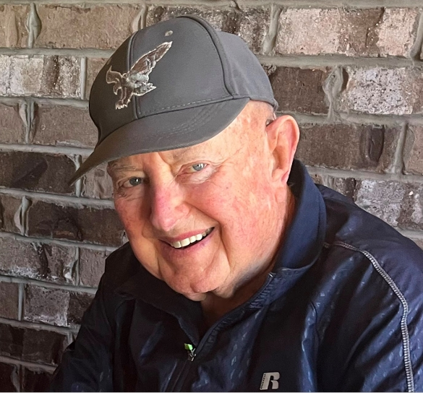

It is with sadness our church mourns the passing of Jim Moffett, a member of Alpine Community Church and our longest living member. Jim was a member of our church for the past 48 years! Born in 1935, Jim passed away on September 10 (his father’s birthday) at a nearby hospice facility, surrounded by his family.
Jim was a pilot and captain in the Marine Corps, flying the same airplane as the Blue Angels used to fly, an A-4 Skyhawk. He then became a pilot for Continental Airlines He and Bonnie lived for several years in Hawaii while Jim was flying in Micronesia.
He and Bonnie then moved to Alpine in 1977 where they became members of our church. Jim was a faithful choir member, served numerous times as church moderator, treasurer and as a church trustee. Jim and his wife Bonnie hosted many church picnics, potlucks, choir Christmas parties , Christmas caroling parties, and summer swim parties at their home in Palo Verde Ranch. Jim remained one of our most active members until his health became an issue these last few years. He retired in 1995.
Jim is survived by his wife, Bonnie, a son, Michael (wife Colleen), daughter Holly (son-in-law Joel) as well as four grandchildren. Jim retired from Continental Airlines in 1995, and son Michael is currently a pilot with Delta. His grandson is now a Delta pilot, marking 3 generations. Services will be held for Jim at the Miramar National Cemetery on October 2.

“Dancing with the Wind”
by Natalia Serna | published on Jun 3, 2022


“The wind blows wherever it pleases. You hear its sound, but you cannot tell where it comes from or where it is going. So, it is with everyone born of the Spirit” John 3:8
That night when Nicodemus and Jesus met up in Jerusalem, things were tense in the city. The gospel of John tells us that Passover was near, and the city was bursting with people. Pilgrims had arrived from all parts of the kingdom. The great Sanhedrin, (the Jewish supreme court) was in session and had its 71 members present. Besides, Pilate was in town. He had marched in with his troops from Cesarea, ready to crack down on any potential uprisings.
We know Nicodemus was part of the Sanhedrin. He was one of the richest and most important men in Jerusalem. It seems the Pharisees (his colleagues) sent him to meet up with Jesus. They probably suspected that the teacher’s presence in town indicated that an uprising was near. They knew how volatile the city could be during Passover and it was their job to keep things under control.
We do not know for sure what motivated Nicodemus to go looking for Jesus at night, what we do know is that the conversation changed his life.

Jesus probably knew from the very start why he was there. He was not one to be fooled. He knew that they were looking to figure him out, they wanted to know his plans and reasons for being in town. And so, the master turned the table on the guest, and spoke of wind and water instead.
You want to know Nicodemus, what’s my plan? look at the wind, and you will know my strategy.
Nicodemus was confused.
Do you remember that before creation, the wind was already there? Before Elohim made the stars, the seasons, the months in the years, the hours in the day. Even before then, the wind was already flying over the waters. Have you paid attention to her? The wind is not like the sun, do not ask her where she will be in three weeks, or when she will pass by your window. No one can control her, no one knows where she goes.
I ask you, Nicodemus. Where are you? Are you tied to the past? Tied to the future? Bound to a bunch of laws and ideas someone taught you? The spirit is much older than your rules. Are you too afraid to let go of having control? That is not how the Kingdom works. Life is a dance with the spirit, The kingdom cannot be controlled. The door ALL, now be like the wind and let go.
I ask you then.
What is tying you down? What weight must you let go off?
Elohim, fill with spirit our hearts. We want to be wind in your wind, we want to let go of what holds us back. Your kingdom is a mystery no one can figure out. Your kingdom is a dance between two lovers, who know not where they will end up.

Care and Prayer List
1

Alpine Community Church Care & Prayer List
Please call or send a greeting card to someone on the list, your thoughtfulness will be appreciated. Names will be removed when it is unknown if the need for prayer still exists. If you have family or friends in need of prayer,

Heide Ayde & Family
Tami Coleman
Pam Ennis
Tatty Fenton
Robert Fuller
Helen Harvey
Sandy Lusink
Bonnie Moffett
Family of Jim Moffett
Jim Nunnally
Jodie Thulin
Family of Sue Truscott
Amy Worland-Renner
Our United States of America, i.e. Dearborn MI
Our Leaders
Military

Police Officers

Firefighters

May Peace Prevail on Earth

Birthdays and Anniversaries

October Birthday Wishes
O’NEAL, Kalista 10/04
O’NEAL, Dee Ann 10/12
DeMEESTER, Janette 10/19
NUNNALLY, Jim 10/21
NELSON, Bruce 10/28

October Anniversaries
BELLAS, Robin 10/05

We can be reached by telephone at (619) 445-2110, or by e-mail at acc1894@acc.sdcoxmail.com. Office hours are Monday – Friday from 9am until noon. Even if we are not here in the office after noon, you can slip envelopes, messages & requests through the mail slot in the office’s front door. Thank You, Denise

Church Office Hours
Please send articles and pictures for the Cross Currents to:
Cross Currents Editor: Pamela Ennis
Email: pamelaennis@cox.net Cell Phone: (619) 249-3739

October 2026
Sunday | Monday | Tuesday | Wednesday | Thursday | Friday | Saturday
ACC – 9am  Pastor Ben & PPC 11am & 5pm services | OFFICE CLOSED on Mondays  B.S. TROOP 105 | CHOIR 7-8:30p | BSF 1-3 (FullerHall) | 1  PPC  Bible Study  6-8pm | 2 | 3  7:00 PM AA
4  9:00a ACC Worship  PPC 10:45am  PPC 5:00pm | 5  OFFICE Closed  B.S. TROOP 105 | 6  Brenda C.  DKG BD mtg– FH 9-12  CHOIR 7-8:30p | 7  ACC Bible Study 9:30  BSF 1-3 (FullerHall)  5:30p – AA, FH | 8  PPC  Bible Study  6-8pm | 9  DH on vacation 10/9-10/19 | 10  Guild MTG 9:30am  7:00 PM AA
11  9:00a ACC Worship  PPC 10:45am  DEACON’S Mtg  PPC 5:00pm | 12  OFFICE Closed  TRUSTEE’s Mtg  B.S. TROOP 105 | 13  CHOIR 7-8:30p | 14  ACC Bible Study 9:30  BSF 1-3  (FullerHall)  5:30p – AA F. Hall | 15  PPC Bible Study 6-8pm | 16 | 17  7:00 PM AA
18  9:00am ACC  PPC 10:45am  CABINET Mtg  PPC 5pm | 19  OFFICE Closed  B.S. TROOP 105 | 20  CHOIR 7-8:30p | 21 ACC Bible Study 9:30  BSF 1-3 (FullerHall)  5:30p – AA F. Hall | 22  PPC  Bible Study  6-8pm | 23 | 24  7:00 PM AA
25  9:00 AM ACC Worship  PPC 10:45am  PPC 5pm | 26  OFFICE Closed  B.S. TROOP 105 | 27  CHOIR 7-8:30p | 28  ACC Bible Study 9:30  BSF 1-3 (FullerHall)  5:30p – AA Fuller Hall | 29  PPC  Bible Study  6-8pm | 30 | 31  7:00 PM AA
9:00 AM ACC Worship
PPC 10:45am
PPC 5pm

Mission Statement
Our Mission as the Alpine Community Church is to serve God by creating an environment of fellowship following the teachings of Jesus Christ. We minister to the needs of our congregation and community, motivating ourselves with love, faith and hope.
Join us for Worship
In person in our sanctuary at 9:00 AM Sunday Mornings
Also on Facebook and Youtube (links found on alpineucc.org)

ALPINE COMMUNITY CHURCH
United Church of Christ
2225 W. Victoria Drive
P.O. Box 212
Alpine, CA 91903-0212
Return Service Requested


CROSS CURRENTS
Published Monthly
Editor Pamela Ennis
Production Manager Denise Horan

The editor welcomes contributions
But they must be received
by the 15th of each month.

